Effect of Total Gas Pressure and O₂/N₂ Flow Rate on the Nanostructure of N-doped TiO₂ Thin Films Deposited by Reactive Sputtering

M.A. Baker¹*, H. Fakhouri² R. Grilli¹, J. Pulpytel², W. Smith^{2,3}, F. Arefi-Khonsari²

¹The Surface Analysis Laboratory, Faculty of Engineering and Physical Sciences, University of Surrey, Guildford, GU2 7XH UK
²Laboratoire de Génie des Procédés Plasma et Traitement de Surface, Université Pierre et Marie Curie, 11 Rue Pierre et Marie Curie, 75231 Paris-France
³Present address: Materials for Energy Conversion and Storage (MECS), Department of Chemical Engineering, Delft University of Technology, P.O. Box 5045, 2600 GA Delft, The Netherlands

*corresponding author
Email: m.baker@surrey.ac.uk
Phone: +44 1483 686294

ABSTRACT

N-doped TiO₂ thin films have been deposited by reactive RF magnetron sputtering at different total gas pressures and varying O₂/N₂ gas flow rates at 300 °C. The thin film nanostructure has been studied by scanning electron microscopy, x-ray diffraction and x-ray photoelectron spectroscopy (XPS). Increasing the deposition pressure leads to reduced crystallinity of the thin films and a higher N₂ flow rate was required to incorporate N into the growing film. This is attributed to the lower energy ion bombardment of the surface and N adatom chemical reactivity being reduced at higher total gas pressures. Ar⁺ ion sputtering of the deposited N-doped TiO₂ thin films has enabled a detailed XPS investigation of the surface and bulk N species to be performed. Adsorbed N species have been identified on all the deposited thin film surfaces, with the most prevalent adsorbed N species occurring at a binding energy of approximately 400 eV, shown to originate from atmospheric contamination, most probably N containing organic species. The bulk N content varies between 0.5 and 6.0 at.% and N is located predominantly at substitutional sites in the TiO₂. The presence of interstitial N, in the form of NO species, has been identified by XPS in some thin films deposited at higher deposition pressures. Hence, varying the total gas pressure may provide a route for tailoring the location of N in the bulk structure. At higher N contents (> 3 at.%), TiN is found as a secondary phase within the bulk structure and the presence of TiN leads to a sharp reduction in the band gap. Post-deposition annealing of low N containing films results in a N-doped TiO₂ single phase anatase structure.

1. INTRODUCTION
TiO₂ has shown extensive utilization in optoelectronic devices, specifically in photocatalysts, dye-sensitized solar cells, and smart-surface technologies. However, its use is limited to UV activation, due to its large band gap energy (E_{g} = 3.2 eV for anatase, E_{g} = 3.0 eV for rutile), and relatively short electron-hole pair lifetime. Many attempts have been made to address these two issues with varying success. The primary efforts in extending the absorption range in TiO₂ from the UV range to the visible spectrum have focused on doping. In particular, great attention has been paid to doping TiO₂ with non-metals such as C, S, and N. Asahi et al. established that nitrogen doping in TiO₂ should be the most effective method to improve visible light photoactivity, due to nitrogen’s small ionic radius and optimal electronic band positions [1].

Reactive magnetron sputtering is a common method for the preparation of TiO₂ and the effects of total gas pressure on the structure and properties of reactively sputtered TiO₂ thin films has been studied by a number of workers [2-5]. An increase in the total gas pressure leads to: (i) a reduction in the crystallinity (or grain size); (ii) a less compact microstructure and rougher surface [4,5]; (iii) an improvement in the photocatalytic properties [2,4,5]. The microstructure obtained with increasing total pressure varied: some authors found that for films deposited at low temperatures and relatively high O₂/Ar gas pressures, the crystalline structure changed from rutile to anatase [3,4] whilst others found a transition from mixed anatase/rutile to anatase [2] or only anatase [5].

N-doped TiO₂ thin films deposited by reactive magnetron sputtering have been examined by a number of authors and in each case, for the authors have characterized the N-doped TiO₂ thin films for their composition, structure and N bonding [6-9]. S.-H. Lee et al. deposited thin films using dry air as the reactive gas at a substrate temperature of 200 °C [6]. The thin films generally exhibited a polycrystalline anatase structure. The N was present in the films up to 2.6 at.% and considered to exist at both susbstitutional and interstitial sites in the thin films dependent on the deposition conditions. Li and Miyake have deposited N-doped TiO₂ at a constant total reactive gas (O₂ + N₂) pressure of 0.16 Pa and varying partial pressures N on unheated substrates [7]. Again all the films showed an anatase structure with a very small rutile content which appears as the N content in the film increases up to 1.0 at.%. The N was concluded to exist at mostly substitutional sites in the lattice with some incorporation of N₂ in the bulk film. Liu et al. employed RF magnetron sputtering of a TiO₂ target in an Ar/N₂ atmosphere at 300 °C [8]. The only variable was the sputtering power (varied between 75 – 130 W) and they observed amorphous structures at the lowest sputter power and then nanocrystalline anatase, with an increase in crystallinity as the power was increased. The N content also increased with sputter power from 2 to 12 at.%. Wong et al. has performed a relatively similar study to that undertaken here, through sputtering in a mixed Ar/O₂/N₂ atmosphere at 250 °C and total pressure of 0.27 Pa but using DC (not RF magnetron) sputtering [9]. As the N₂/(N₂+O₂) fraction was increased, the N content increased up to 21 at.%. For N contents < 1.5 at.%, an anatase structure was observed, but the sharp increase in N content to 21 at.% resulted in the formation of a single crystalline TiN phase observable by X-ray diffraction (XRD). In the N-doped anatase thin films, N was only observed at substitutional sites.

In this investigation, the effect of varying both the total gas pressure and N₂/(N₂+O₂) ratio in RF reactive magnetron sputtered thin films will be investigated. Changes in thin film growth mode, composition, structure and N bonding will be studied using scanning electron microscopy (SEM) cross-sections, XRD and X-ray photoelectron spectroscopy (XPS). Changes in the optical band gap are also presented to correlate with changes in the nanostructure identified by the characterisation techniques. In order to identify the origin of the XPS N 1s components, XPS will be performed before and after Ar⁺ ion sputtering in an attempt to distinguish between N species bonded at the surface and in the bulk of the thin films. Furthermore, changes in the bulk structure after annealing for 1 hour at 450 °C in air will be studied by XRD.

2. EXPERIMENTAL
The pure and N-doped TiO₂ thin films were prepared by a RF reactive magnetron sputtering system (SPT 120, Plasmionique). A metallic Ti target (50 mm diameter) having a purity of 99.95%, was sputtered in a reactive gas atmosphere containing Ar, O₂ and N₂ for the N-doped TiO₂ films, and just Ar and O₂ for the pure TiO₂ films. The deposition pressure was controlled by the Ar flow rate into the deposition chamber, fabricating films at p = 0.40, 0.93 and 1.87 Pa with corresponding Ar flow rates of 30, 70, and 140 sccm respectively. Different nitrogen to oxygen ratios were used depending on the working pressure. The RF cathode power was 200 W for all the depositions. The deposition was undertaken in the intermediate region between two stable sputtering modes, reactive and metallic and was finely controlled by following the optical emission intensity (OEI) of the Ti lines (at 499.1 nm and 419 nm) and normalising these to the Ar OEI line (at 811 nm). The spectra were acquired through an optical fiber using a spectrometer (Maya 2000+ from Ocean Optics). In order to get reproducible coatings, the Ti/Ar OEI ratio between has been kept constant for all depositions. In order to achieve these optimal deposition conditions, the total reactive gas flow rate was fixed at 2.0, 2.3, 2.5 sccm for the samples deposited at 0.40, 0.93 and 1.87 Pa respectively. For convenience, the nomenclature ‘nitrogen ratio’ for each sample will be employed to describe the ratio of the nitrogen flow rate to the total reactive gas input. For example, when the nitrogen flow rate is 0.6 sccm, and the oxygen flow rate is 1.4 sccm, then this sample has a nitrogen ratio of 30 %, since nitrogen is 30 % of the total reactive gas flow rate (2.0 sccm).

The substrate holder was maintained at 300 °C and the distance between the substrate holder and the target was fixed at 10 cm. The initial base pressure was 0.4-0.9 x 10⁻³ Pa, while the total working pressure was between 0.40 and 1.87 Pa. Prior to each deposition, the target was pre-sputtered in an Ar atmosphere for 10 minutes to remove any contamination from the target surface. The substrates used were Si (100) and ordinary microscope glass slides. Prior to deposition, the substrates were ultrasonically cleaned with acetone, ethyl alcohol and then de-ionized water for 20 minutes each. The films were investigated in the as-deposited state and after annealing for 1 hour in air at 450 °C.

The crystal structure of the as-deposited thin films was characterized by glancing angle X-ray diffraction (XRD) using an X’Pert Pro MPD diffractometer with an incident angle of 1°. The annealed samples were analysed in the Bragg-Brentano (θ-2θ) configuration using X’Pert Pro PW3040-Pro diffractometer. In both cases, a Cu Kα (λ = 1.5418 Å) radiation source was employed. Electron microscopy was undertaken using an FEI Quanta FEG 200 electron microscope at an acceleration voltage of 20 keV. Micrographs were recorded on the thin film cross-sections after cleaving the Si substrates.

XPS analysis of the as-deposited samples was performed on a ThermoFisher Scientific Microlab 350 spectrometer employing Al Kα non-monochromated radiation (1486.6 eV) with a power of 300 W, and a take-off angle (relative to the surface normal) of 0º. XPS analysis was further performed on these same samples at a later date using a ThermoFisher Scientific Thetaprobe, employing Al Kα monochromated radiation with a power of 140 W and take-off angle of 37°. Ar⁺ ion sputtering of the thin films analysed in the Thetaprobe was performed using an incident energy of 1 keV. The binding energies were calibrated with respect to the adventitious aliphatic carbon contamination peak at 285.0 eV and an analyser pass-energy of 50 eV was employed (on both instruments) for elemental peak analysis. Curve fitting was performed with the ThermoFisher Scientific Avantage software after subtraction of a Shirley background and quantification performed using instrument modified Wagner sensitivity factors.

Transmission and reflection optical spectra were recorded using a UV-vis spectrophotometer (Varian 6000) at normal incidence. From the transmission spectra, Tauc plots were constructed using indirect transitions and the optical band gap estimated from plotting (αhν)^{1/2} vs. hν (where α is the absorption coefficient) and by extrapolating the linear part of the curve to the x-axis (hν), the band gap energy was obtained.

3. RESULTS

3.1. SEM
The effect of total gas pressure on the thin film microstructure is well-known from the structure-zone diagram of Thornton [10]. Figure 1 shows SEM cross-sections of the films deposited at 0.40, 0.93 and 1.87 Pa. The film thickness varies between 1.3 and 2.3 µm. It can be seen that all the films exhibit a columnar structure and there is not a large difference in the structure between the films deposited at the different pressures. However, at lower gas pressures the film is very dense and compact with a fine semi-columnar structure and as the gas pressure is raised, the thin films increase in surface roughness and develop a slightly coarser columnar structure.

3.2. GAXRD

The GAXRD data for the coatings deposited at 0.40, 0.93 and 1.87 Pa is shown in Figure 2. At a deposition pressure of 0.40 Pa, the 15 % N ratio thin film show peaks corresponding to nanocrystalline anatase. The 30 % N film is amorphous and 35 % N ratio thin film exhibits broad, low intensity (111), (200) and (220) peaks of TiN. At the higher deposition pressure of 0.93 Pa, the 26 % N ratio thin film shows an amorphous structure. The 35 and 48 % N ratio thin films at this pressure both exhibit (111), (200) and (220) TiN peaks, with the 48 % N coating showing sharper peaks, indicative of a larger grain size. All the coatings deposited at 1.87 Pa exhibited amorphous nanostructures.

For the 0.40 and 0.93 Pa coatings deposited at higher N ratios, the TiN diffraction peaks were observed at very similar peak positions. The TiN (111), (200) and (220) peaks were found at 2θ values of 37.8°, 43.9° and 63.4° (for the 0.93 Pa 48 % N ratio coating) respectively. Compared to the JCPDS 38-1420 peak positions for TiN, these observed peaks all show a shift to higher 2θ values by 1.0 – 1.5°, caused by tensile stresses within these nanocrystallites and/or incorporation of O into the TiN structure, leading to a contraction of the lattice parameter.

The XRD scans for the thin films annealed at 450 °C for 1 hour are presented in Figure 3. For the thin films deposited 0.40 Pa, at N ratios of 15 % and 30 %, a single phase anatase structure is observed. At the higher N ratio of 35 %, the predominant crystalline phase is TiN with a small and broad anatase (101) peak also observed in the spectrum indicating the additional presence of a nanocrystalline anatase phase. For the higher deposition pressure of 0.93 Pa, at a low N ratio of 26 %, again, a single phase anatase structure is observed after annealing. At a N ratio of 35 % a dual phase anatase/TiN structure is observed, with anatase being the more crystalline of the two phases. For the highest N ratio of 48 %, similar to the 0.40 Pa 35 % N thin film, TiN is the dominant crystalline phase but a low intensity anatase (101) peak can be seen indicating the presence of nanocrystalline anatase in the thin film. At the highest deposition pressure of 1.87 Pa, all three of the thin films exhibit a single crystalline anatase phase and no nanocrystalline TiN is observed, even at higher N ratios. At this deposition pressure, an increase in the N content leads to a change in the preferential orientation of anatase from the (004) to (101) direction.

3.3. XPS

Peak fitted XPS N 1s spectra from the as-deposited coating surfaces are given in Figure 4 and quantified XPS N concentrations are presented in Table 1. The correct assignment of N 1s components for N-doped TiO₂ thin films is not straight-forward as there are conflicting views in the literature on the binding energies attributable to the different N substitutional and interstitial species which may occur in the N-doped TiO₂ structure. Furthermore, the XRD results above have shown the presence of a TiN phase within some of the films and N may also be present on the surface as chemisorbed or contaminant species.

Concerning the N species observed, peak fitting has shown that there are 4 major components. These are at binding energies of 396.3 ± 0.2 eV (N1), 397.2 ± 0.2 eV (N2), 400.1 ± 0.2 eV (N3) and 402.1 ± 0.2 eV (N4). The N1 component, at 396.3 ± 0.2 eV, is widely accepted to correspond to N bonding to Ti and substituting for O in the TiO₂ structure [6,7,11-18]. N2, at 397.2 ± 0.2 eV corresponds to TiN [19,20]. The third component, N3, at 400.1 ± 0.2 eV has many possible origins. Firstly, adsorbed species: some workers have assigned a peak at binding energies around 400 eV to adsorbed N₂ species [1,19,16,21], whilst others have noted that a peak at this energy is also found for pure TiO₂ or disappears after sputtering implying that this peak is associated with adsorbed species (surface contamination), but not specifying the origin [22]. However, many researchers have assigned a peak at very similar binding energies to interstitial nitrogen [6,8,13,22,24]. The final component, N4, at 402.1 ± 0.2 eV, has been ascribed to various different adsorbed species: unscreened N₂ [1,19], NO dimers [21] and an unknown surface specific chemisorbed species [23].

With regard to the effects of surface contamination, representative XPS N 1s spectra for two of the thin films (grown at different deposition pressures) after varying (short and long) exposure times to atmosphere are presented in Figure 5. In all cases, it is clear that the N 1s peakshape changes as the exposure time to atmosphere increases. Specifically, the N 1s component with binding energies in the range 399.5 - 400.0 eV clearly grows in intensity with exposure time to atmosphere. These peaks are also found for the pure TiO₂ thin films deposited at different total gas pressures in Figure 6. Hence, such species are N containing molecules which are being progressively adsorbed at the surface as a function of time. Determining the exact nature of the adsorbed N species is outside of the remit of this paper, which is focused on understanding the bulk nanostructure of these thin films. However, for the two thin films shown in Figure 5, it was noted that the longer exposure time results in the C 1s peak and the N 1s 400 eV peak both increase in intensity by a factor of approximately 3. Hence, it is highly likely that the 400 eV peak is associated with N containing organic species and not adsorbed N₂, as reported by many other workers. In keeping with the terms ‘substitutional N’ and ‘interstitial N’ for bulk N species, these different N containing species adsorbing at the surface will be referred to as ‘adsorbed N’ in this paper.

The presence of adsorbed N species on the thin film surfaces raises the question of whether the XPS N 1s peak components observed in the as-deposited thin film samples (Figure 4) are comprised of both adsorbed and bulk N species. To determine the nature of N in the N-doped TiO₂ thin films, it is important to identify just those N species which are present in the bulk. Consequently, all of the coatings were Ar⁺ sputter etched to remove any adsorbed species. An Ar⁺ ion energy of 1 keV was employed in an attempt to minimise the damage and penetration depth of Ar⁺ ions within the surface. For the XPS Thetaprobe configuration, the penetration of 1 keV Ar⁺ ions in TiO₂ is approximately 1.2 nm (determined using SRIM simulation software). The samples were sputter etched until no further change was observed in the N 1s spectral peak shape and the results given in Figure 6. For all of the sputtered samples, the C concentration after sputtering was < 2 at.%.

Considering first the XPS results for the thin films before sputtering, it can be seen from Table 1 that the N concentration varies significantly with N % ratio, and in all cases rise as the N % ratio is increased. For low N concentrations (< 1 at.%), the N3 and N4 peaks at approximately 400 and 402 eV dominate and only the 0.93 Pa 26 % N thin film shows a low binding energy N1 peak at 396.2 eV. However, as the N % ratio is increased, the low binding energy N1 component becomes the prominent peak, together with a smaller N2 component. This trend is observed for the thin films deposited at all pressures.

After sputtering, for the pure TiO₂ thin films, all N species are removed from the surface. The N 1s peak for the thin films with low N contents changes substantially after sputtering, with the N4 component at 402 eV being removed, the N3 component at 400 eV being strongly reduced in intensity and a small N1 peak appearing at low binding energies for all films. The trace N level observed for the 1.87 Pa thin film may have arisen due to the slightly higher roughness of this film compared to films deposited at lower pressures causing a minor shadowing effect of the incident Ar⁺ beam. For the thin films with N contents > 1 at.%, the most prominent N component is now shifted from being the N1 peak at around 396 eV to being the N2 peak at approximately 397 eV.

In light of the XPS data before and after sputtering and also taking into account the GAXRD results, changes in the N 1s peak and nature of the N species present in the XPS spectra can now be considered in detail. Firstly, it is important to note Ar⁺ ion bombardment of TiO₂ leads to preferential sputtering of oxygen [25-28] but TiN does not suffer from preferential sputtering effects [29,30]. It has already been established that the N4 peak at 402 eV corresponds to ‘adsorbed N’ species and the disappearance of this peak after sputtering is in agreement with this assignment. The N3 peak at 400 eV is removed for all the pure TiO₂ coatings and 0.40 Pa 26 % N coating. This peak remains on the other low N containing coatings but is significantly reduced in intensity after sputtering. It has been described earlier that the 400 eV peak could be ascribed to ‘adsorbed N’ or ‘interstitial N’. Any adsorbed species would be expected to be removed from the surface after sputtering, as seen pure TiO₂ thin films, and the presence of a small peak for the samples deposited at higher pressures after sputtering is indicative that interstitial N is present in the bulk of these thin films in addition to substitutional N. It is interesting to note that this 400 eV peak is not only present in the low N containing samples deposited at 0.93 and 1.87 Pa, but there is also a shoulder in the total N 1s peak envelope at around 400 eV for the thin films deposited at 0.93 and 1.87 Pa with higher N contents which is absent for the thin films deposited at 0.40 Pa.

The N1 component at around 396 eV is observed for all the thin films after sputtering. For the two thin films where no N1 component was observed prior to sputtering (0.40 Pa 15 % N and 1.87 Pa 40 % N), it seems surprising that a ‘substitutional N’ peak appears after sputtering, but it is probable that a very small concentration of ‘substitutional N’ in the bulk was being masked by the presence of surface contaminants. Of more interest, is the reduction in the intensity of the N1 component after sputtering for the high N containing samples and the concomitant increase in the N2 397 eV component.

In view of the GAXRD results, this behaviour can be explained by the surface oxide of TiN being etched away as a result of sputtering, exposing the bulk TiN phase [19]. The remaining N1 peak thus represents the presence of ‘substitutional N’ in the N-doped TiO₂ phase in addition to N bonded in TiN for these thin films. As the 397 eV TiN peak is present with a higher intensity in some samples, a further peak is now required in the peak fit (between 398 and 399 eV) corresponding to the associated shake up satellite [30].

It is useful to plot the XPS determined N concentration as a function of the N ratio for the different deposition pressures, given in Figure 7 (a). As the N concentration in the XPS spectra is affected by both by the ‘adsorbed N’ (as-deposited spectra - Figure 4) and preferential sputtering effects (after sputtering spectra – Figure 6), it is not possible to obtain definitive values for the N content of the bulk thin films. Hence, in Figure 7 (a), it was decided to use the N contents determined from the as-deposited spectra (excluding the C concentrations – considered to be surface hydrocarbon species), as the main trend in the results is still clear, but the associated errors should be borne in mind. Figure 7 (a) yields the following important information: as the deposition pressure is raised from 0.40 to 1.87 Pa, the N₂ concentration in the sputter gas mixture needs to be progressively increased to incorporate N into the growing film.

3.4. Band gap

The optical band gap for the deposited thin films before and after a 1 hour anneal is shown in Figure 7 (b). The trend in this data before and after annealing is remarkably similar to that of Figure 7(a). For the films deposited at all pressures, a small amount of N doping leads to a slight reduction in the band gap, as is expected for N-doped TiO₂ [1]. However, there is a sharp narrowing of the band gap as the N content in the thin film increases above 1 at.%. For the thin films deposited at different pressures, the onset of this band gap narrowing is observed at higher N ratios as the deposition pressure increased. The origin of the strong band gap narrowing can be understood from the GAXRD data in Figure 2. Once TiN (a material with metallic-like conductivity) starts to form, the presence of this second phase within the thin film causes an abrupt reduction in the band gap energy. These results are consistent with the appearance of the thin films, where all of the TiN containing samples were either slightly dark in appearance or opaque, with the other films being transparent (yellow or colourless).

4. DISCUSSION

4.1. Effect of deposition pressure
The effect of total gas deposition pressure on the coating macrostructure has already been noted from the SEM images (Figure 1), where a more compact structure arises at low total gas pressures. This is consistent with the micrographs presented by Zeman and Takabayashi [4]. The GAXRD results in Figure 2 also show a clear trend of gas pressure on nanostructure. The films deposited at lower deposition pressures are more crystalline than those deposited and at higher gas pressures, with all the thin films deposited at 0.40 Pa being nanocrystalline and all those deposited at 1.87 Pa being amorphous. A similar trend of reduced crystallinity at higher total gas pressures is observed for reactively sputtered TiO₂ thin films [4]. The observed changes in macrostructure and nanostructure of the films occur due to an increased number of gas atom collisions at higher pressures. This decreases the kinetic energy of both the sputtered atoms arriving at the surface and ions bombarding the substrate causing a reduction in the surface mobility of the adatom species.

It has been seen in Figure 7(a) that the N₂ ratio required to incorporate N into the TiO₂ bulk increases with total gas pressure. This behaviour is related to the excitation state and energy of the depositing species. It has been shown that the chemical reactivity of the reactive gas species is affected by plasma density [31,32] and deposition temperature [33], giving rise to more excited gaseous and adsorbed species, yielding increased surface diffusion of adatoms and faster reaction rates. For a similar materials system, Zabinksi et al. have also reported that the N content of aluminium oxynitride thin films is enhanced at lower total gas pressures [33]. The results given by Zabinski et al. and those reported here in Figure 7(a) indicate that at lower gas pressures, more reactive species of N arrive at the surface, hence less N₂ is required in the reactive gas mix to promote incorporation of N into the bulk TiO₂ film.

The total pressure does not seem to substantially affect the ability of TiN to form as a secondary phase, this is more dependent on the total N content in the bulk. The incorporation of N as ‘substitutional N’ also appears to be independent of deposition pressure, with all films showing the presence of ‘substitutional N’ in the thin films. This is consistent with other reactive sputtering studies on N-doped TiO₂ thin films, where the ‘substitutional N’ is the dominant location of N in the bulk structure [6-9,22,24]. The results in Figure 6 indicate that the formation of interstitial N may be more strongly promoted at higher total pressures (the interstitial N peak being absent at the lowest pressure of 0.40 Pa). For N-doped TiO₂ powders, Di Valentin et al. have compared the results of electron paramagnetic resonance (EPR) spectra with theoretical calculations and concluded that the interstitial N state can be attributed to NO species which interact with the Ti atoms through their π bonding states [34]. Following careful consideration of various theoretical and experimental works, Oropeza et al. have concluded from their XPS and EPR studies of sol-gel deposited N-doped TiO₂ that the XPS N 1s peak they observe at around 400 eV also corresponds to interstitial N bound to lattice O to give an NO-like species [35]. Hence, it may be that at higher pressures, NO adatom species formed either in the plasma [33] or as adatom heterogeneous reaction products are being directly incorporated into the growing film due to the low kinetic energy of adatom species, whilst at lower pressures the adatoms have sufficient energy to dissociate the adsorbed NO molecules and N atoms are then incorporated at substitutional sites within the TiO₂. Hence, varying the total gas pressure may be a route for tailoring the location of N in the bulk structure.

4.2. Effect of N content on the Thin Film Crystallinity
For the as-deposited thin films, at low concentrations of N incorporated into the film (< 1 at %), a single phase structure of N-doped TiO₂ (anatase) is formed at 0.40 Pa, with amorphous N-doped TiO₂ formed at the higher deposition pressures of 0.93 and 1.87 Pa. The 3.0 at.% N thin film deposited at 0.40 Pa shows an amorphous structure, which is unexpected since there is enhanced surface diffusion of adatom species at low pressures, however this can be explained by the higher concentration of N inhibiting the formation of nanocrystalline N-doped TiO₂, but not being sufficiently high for nanocrystalline TiN to form.

It is interesting to note that after a 1 hour annealing treatment, all of the thin films which in the as-deposited state have low N contents (up to 3.0 at.% N) and show amorphous structures, exhibit preferential orientation in (004) direction compared to the standard relative intensities for anatase (JCPDS no. 84-1286). Whereas, the as-deposited nanocrystalline N-doped TiO₂ thin film (0.40 Pa 15 % N) shows the more typical (101) preferential orientation of anatase. Hence, in the absence of initial nanocrystal formation in the as-deposited state, N-doping appears to influence the nanocrystalline anatase structure which develops during this annealing process, leading to a rather uncharacteristic (004) preferential orientation for the thin films.

Above 3 at.% N, at pressures of 0.40 and 0.93 Pa, TiN is observed as a secondary crystalline phase in addition to N-doped TiO₂, with the latter phase being amorphous. The presence of nanocrystalline TiN but amorphous N-doped TiO₂ phase might be considered surprising, since, even for the sample containing the highest N, the maximum possible phase fraction of TiN in the dual phase TiN + N-doped TiO₂ structure is around 20 mol.% (based on a Ti bulk concentration of 25-26 at.%). Hence, the predominant phase is always N-doped TiO₂. Anatase and rutile exhibit more complex tetragonal structures compared to cubic TiN, hence nanocrystalline TiO₂ formation may be kinetically hindered compared to TiN. Alternatively, the amorphous nature of the N-doped TiO₂ phase may result from the incorporation of N into TiO₂ leading to some distortion of the TiO₂ lattice [36] and the competitive grain growth of TiN and N-doped TiO₂ adversely affecting the formation of crystalline anatase.

Following the initial formation of TiN, when the N content is > 5 at.%, the presence of this phase appears to hinder the formation of a crystalline N-doped TiO₂ phase after annealing (with only a poorly crystallised or amorphous phase being observed) and this again is most probably due to the grain growth of TiN leading to internal strain and a distortion of the TiO₂ crystalline structure. For the other thin films, with lower N content, after annealing, a well-crystallised anatase phase is observed, as would be expected. The formation of a crystalline TiN phase at higher N concentrations has only been reported by Wong and Chou [9]. However, other authors have noted either a reduction in the band gap at higher N concentrations [7,8] or a darkening of the thin films [6], indicative that a TiN secondary phase is probably forming in the thin film.

5. CONCLUSIONS

N-doped TiO₂ thin films have been deposited by reactive RF magnetron sputtering at different O₂/N₂ gas flow rates and varying total gas pressures at 300 °C. XPS and XRD analysis has shown how the chemical composition and crystal structure of the N-doped TiO₂ changes with N₂ flow rate and deposition pressure. Of particular interest are the XPS results which indicate that varying the total gas pressure could offer a route for tailoring the location of N species (substitutional N or interstitial NO) in the bulk structure. Detailed conclusions from the work are given below:

N-doped TiO₂ thin films have been deposited by the reactive RF magnetron sputtering of a Ti target with varying O₂/N₂ flow rates and different total gas pressures. The total N content in the film varies between 0.5 and 6.0 at.%. Raising the total deposition pressure results in increased amorphisation of the deposited films and higher N₂ flow rates required to incorporate N into the growing thin film. This behaviour occurs as a result of the increased gas pressure causing a reduction in both the N adatom reactivity and ion bombardment energy of the surface.
At all deposition pressures and N content, N is predominantly located at substitutional sites within the bulk TiO₂ structure, but interstitial N has been identified in some thin films, deposited at higher total pressures. Hence, varying the total gas pressure may offer a route for tailoring the location of N in the bulk structure. Increasing the N content in the film to > 3 at.% results in the formation of a secondary TiN phase in addition to N-doped TiO₂. The presence of TiN in the bulk leads to a sharp reduction in the band gap.
XPS combined with Ar⁺ ion sputtering of the surface has shown the presence of adsorbed N species on all the deposited thin film surfaces. The most intense N 1s component associated with adsorbed N species occurs at a binding energy of approximately 400 eV and is shown to originate from atmospheric contamination, most probably N containing organic species.
For thin films with lower N contents, a 1 hour anneal at 450 °C results in a highly crystalline anatase being formed. For N-doped TiO₂ thin films which are initially deposited in the amorphous state, the N-doping appears to influence the nanocrystalline anatase structure which develops during this annealing process, leading to a rather uncharacteristic (004) preferential orientation for the thin films.

ACKNOWLEDGEMENTS

The authors are very grateful for funding provided by the European Commission FP7 NATIOMEM project (245513-2).

REFERENCES:

[1] R. Asahi, T. Morikawa, T. Ohwaki, K. Aoki, Y. Taga, Science, 293 (2001) 269
[2] J.Šícha, J.Musil, M.Meissner, R.Čerstvy Applied Surface Science, 254 (2008) 3793
[3] S.S.Pradhan, S.K.Pradhan, V.Bhavanasi, S.Sahoo, S.N.Sarangi, S.Anwar, P.K.Barhai Thin Solid Films 520 (2012) 1809
[4] P.Zeman, S.Takabayashi Surface and Coatings Technology, 153 (2002), 93
[5] J.O.Carniero, V.Teixeira, A.J.Martins, M.Mendes, M.Ribeiro, A.Vieira Vacuum, 83 (2009) 1303
[6] S.-H.Lee E.Yamasue, H.Okumura, K.N.Ishihara Materials Transactions 50, (2009) 1805
[7] Z.G.Li, S.Miyake Applied Surface Science, 255 (2009) 9149
[8] B.Liu, L.Wen, X.Zhao Solar Energy Materials and Solar Cells 92 (2008) 1
[9] M.-S.Wong H.P.Chou Thin Solid Films 494 (2006) 244
[10] J.A.Thornton Journal of Vacuum Science and Technology 11 (1974) 666
[11] R. Asahi, T. Morikawa, Chemical Physics, 339 (2007) 57
[12] L. Mi, P. Xu, P.N. Wang, Applied Surface Science, 255 (2008) 2574
[13] O. Diwald, T.L. Thompson, T. Zubkov, E.G. Goralski, S.D. Walck, J.T. Yates, Jr. J.Phys. Chem. B, 108 (2004) 6004
[14] I. Takahashi, D.J. Payne, R.G. Palgrave, R.G. Egdell, Chemical Physics Letters, 454 (2008) 314
[15] M. Batzill, E.H. Morales, U. Diebold, Chemical Physics, 339 (2007) 36
[16] S.H. Cheung, P. Nachimuthu, A.G. Joly, M.H. Engelhard, M.K. Bowman, S.A. Chambers, Surface Science, 601 (2007) 1754
[17] H. Matsui, H. Tabata, N. Hasuike, H. Harima, B. Mizobuchi, Journal of Applied Physics, 97 (2005) 123511
[18] H.M. Yates, M.G. Nolan, D.W. Sheel, M.E. Pemble, Journal of Photochemistry and Photobiology A: Chemistry, 179 (2006), 213
[19] N.C.Saha, H.G.Tompkins Journal of Applied Physics 72 (1992) 3072
[20] M.A.Baker, T.P.Mollart, P.N.Gibson, W.Gissler Journal of Vacuum Science and Technology A 15 (1997) 284
[21] T.Herranz, X.Deng, A.Cabot, Z.Liu, M.Salmeron Journal of Catalysis 283 (2011) 119
[22] K.Obata, H.Irie, K.Hashimoto Chemical Physics 339 (2007) 124
[23] R.G.Palgrave, D.J.Payne, R.G Edgell Journal of Materials Chemistry 19 (2009) 8418
[24] M-H.Chan, F-H.Lu Thin Solid Films 518 (2009) 1369
[25] T.Kubart, T.Nyberg, S.Berg, J. Phys. D: Appl. Phys., 43 (2010) 205204
[26] L.I.Vergara, I.Vaquila, J.Ferron, Applied Surface Science 151 (1999) 129
[27] O.P.Ivanova, A.V.Naumkin, L.A.Vasilyev, Vacuum 46 (1995) 363
[28] E.R.Fuoco, G.Gillen, M.B.J.Wijesundara, W.E.Wallace, L.Hanley, J.Physical Chemistry B 105 (2001) 3950
[29] M.A.Baker, S.J.Greaves, E.Wendler, V.Fox Thin Solid Films 377-378 (2000) 473
[30] I.LeR.Strydom, S.Hofmann Journal of Electron Spectroscopy and Related Phenomena 56 (1991) 85
[31] A.D.Yeadon, S.J.Wakeham, H.L.Brown, M.J.Thwaites, M.J.Whiting, M.A.Baker Thin Solid Films, 520 (2011) 1207
[32] P.K.Barhai, N.Kumari, I.Banerjee, S.K.Pabi, S.K.Mahapatra Vacuum, 84 (2010) 896
[33] J.S.Zabinski, J.J.Hu, J.E.Bultman, N.A.Pierce, A.A.Voevodin Thin Solid Films 516 (2008) 6215
[34] C. di Valentin, G.Pacchioni, A.Selloni, S.Livraghi, E.Giamello Journal of Physical Chemistry B 109 (2005) 11414
[35] F.E.Oropeza, J.Harmer, R.G.Egdell, R.G.Palgrave Physical Chemistry Chemical Physics 12 (2010) 960
[36] N.Martin, R.Sanjinés, J.Takadoum, F.Lévy Surface and Coatings Technology 142-144 (2001) 615

Table 1 : XPS determined surface composition for the unannealed N-doped TiO₂ thin films deposited at 0.40, 0.93 and 1.87 Pa
N Ratio  [N₂/(N₂+O₂)] | Pressure (Pa) | C  (at%) | N  (at.%) | Ti  (at.%) | O  (at.%)
15 | 0.4 | 9.5 | 0.5 | 25.2 | 64.8
30 | 0.4 | 8.3 | 3.0 | 25.3 | 63.4
35 | 0.4 | 9.8 | 5.0 | 25.4 | 59.8
26 | 0.93 | 6.4 | 0.7 | 25.3 | 67.6
35 | 0.93 | 7.4 | 4.4 | 25.1 | 63.1
48 | 0.93 | 6.9 | 5.6 | 26.0 | 61.5
40 | 1.87 | 5.5 | 0.6 | 25.1 | 68.8
48 | 1.87 | 5.3 | 0.8 | 26.3 | 67.6
60 | 1.87 | 6.2 | 3.1 | 25.1 | 65.6

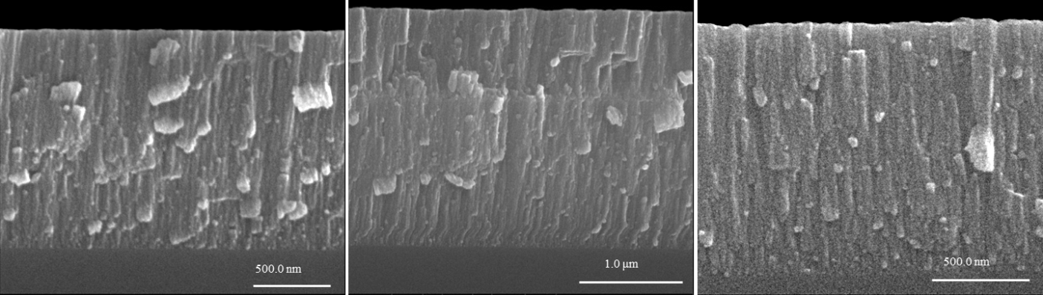

Figure 1: SEM micrographs of anannealed films deposited at: (a) 0.40 Pa; (b) 0.93 Pa and (c) 1.87 Pa.

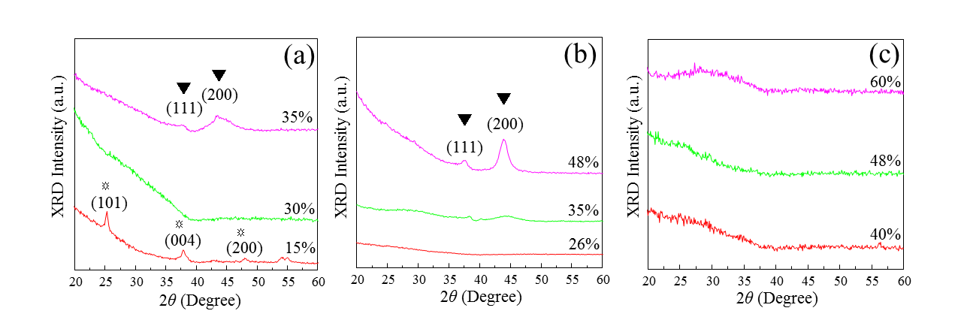
Figure 2: GAXRD diffractograms of unannealed films deposited at (a) 0.40 Pa; (b) 0.93 Pa and (c) 1.87 Pa with different N ratios. (☼ and ▼ refer to anatase TiO₂ and TiN phases respectively).

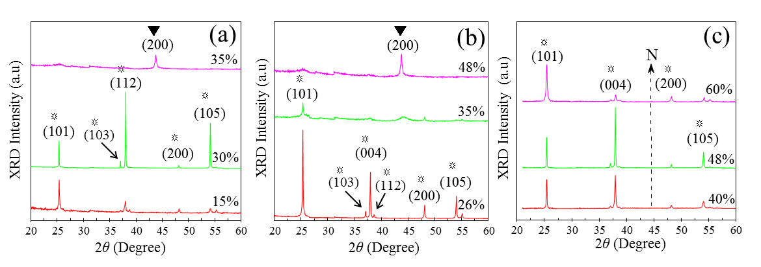
Figure 3: XRD diffractograms of unannealed films deposited at (a) 0.40 Pa; (b) 0.93 Pa and (c) 1.87 Pa with different N ratios. (☼ and ▼ refer to anatase TiO₂ and TiN phases respectively).

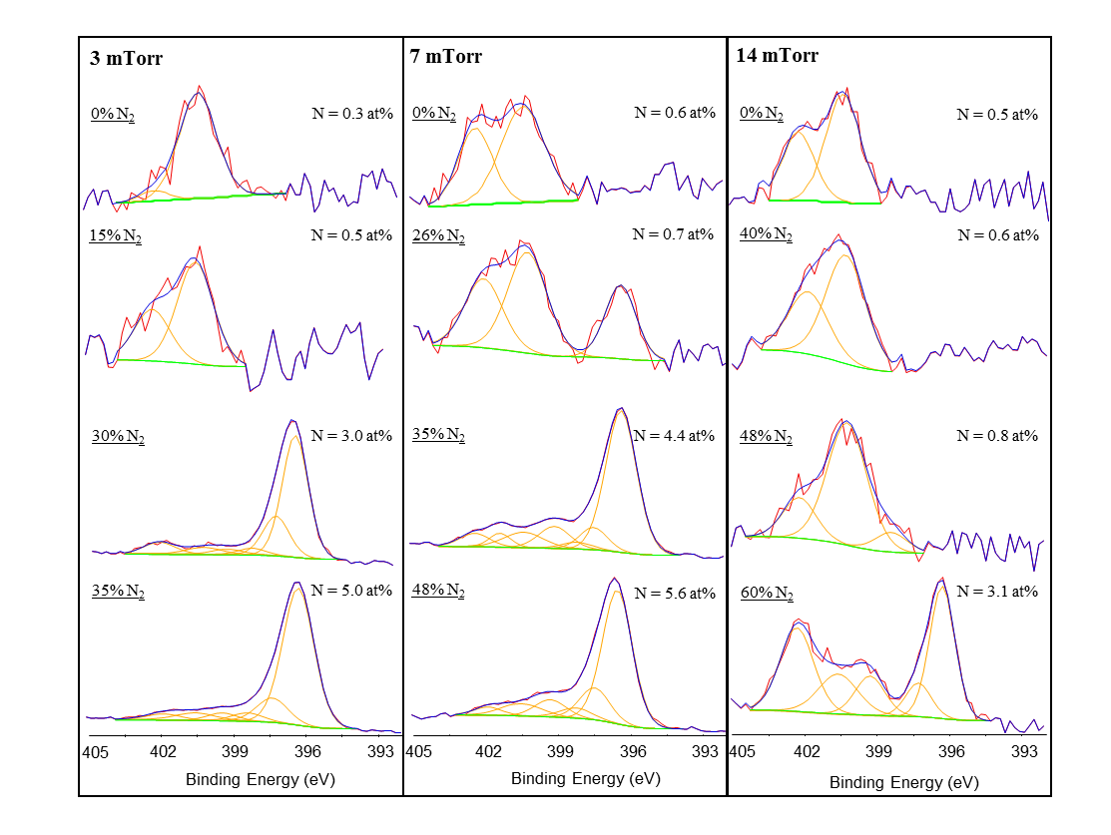
Figure 4: XPS N 1s spectra for the 0.40, 0.93 and 1.87 Pa unannealed thin films recorded prior to sputtering.

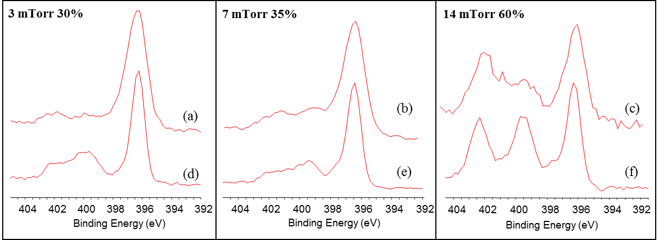

Figure 5: XPS N 1s spectra recorded for the 0.40 Pa 30% N₂ and 1.87 Pa 60% N₂ unannealed thin films deposited some weeks after deposition (a) and (b) and again some months later (c) and (d).

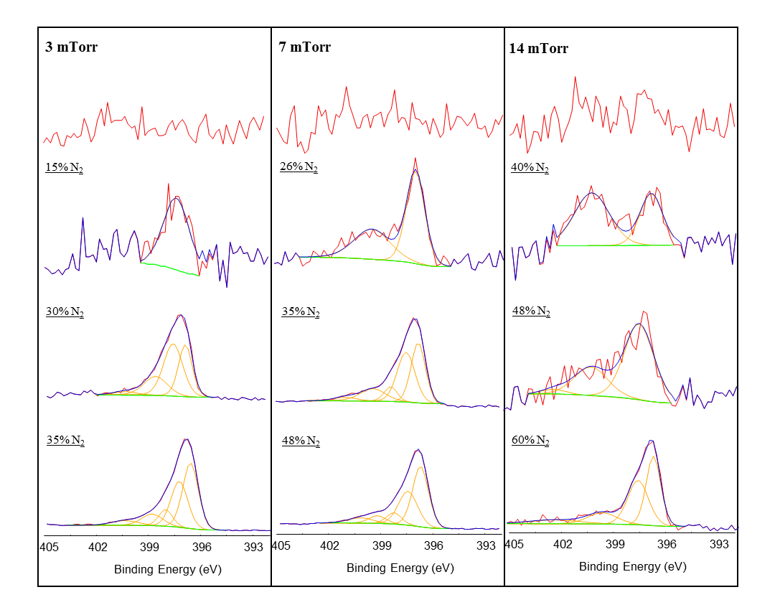
Figure 6: XPS N 1s spectra for the 0.40, 0.93 and 1.87 Pa unannealed thin films recorded after sputtering (until no further changes in the spectra were observed).

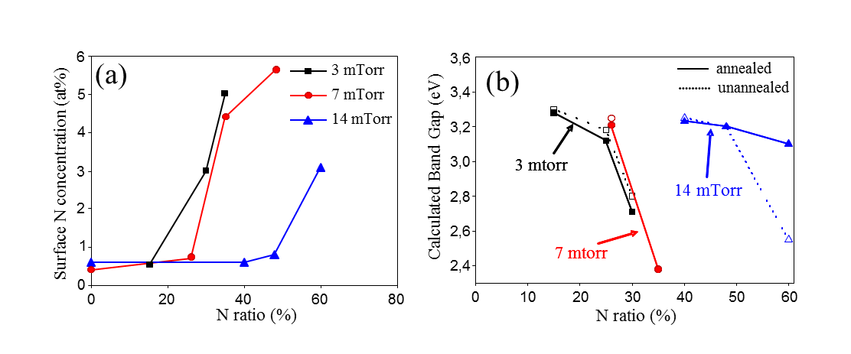
Figure 7: (a) XPS determined surface N concentration and (b) calculated band gap for the N-doped TiO₂ thin films deposited at 0.40, 0.93 and 1.87 Pa with different N ratios

